Shadowrealm Emporium
Card Entry Standard Operating Procedure
A step-by-step guide for entering cards into the inventory app
Website: shadowrealmemporium.netlify.app
SECTION 1 · Opening the Website

The website is saved in your bookmarks bar — the row of shortcuts at the very top of the screen, just below the address bar.

ℹ️ | 👆 Everything in this guide uses TAP (touch the screen once) instead of a mouse click.  If you make a mistake — don't worry. Nothing is permanent until you tap SAVE.

1 | Wake the screen | Tap the screen once to make sure it is on and showing the desktop or browser.
2 | Find the bookmarks bar | Look at the TOP of the Google Chome window. You will see a row of saved site names just below the address bar. It looks like a row of small grey buttons.
3 | Find 'Shadowrealm' | Look along that row for a button that says SHADOWREALM or EMPORIUM. Tap it ONE time.
4 | If you can't find it | Tap the three dots (⋮) at the top right corner of the browser → tap 'Bookmarks' → find Shadowrealm Emporium and tap it.

🌐 | 🔗 Direct link: https://shadowrealmemporium.netlify.app/  If all else fails, type this address into the address bar at the top of the browser.

SECTION 2 · Getting into Inventory Mode

When the website opens, tap the big INVENTORY MODE button.

1 | Tap 'Inventory Mode' | Tap the button that says 'Inventory Mode — Count & update card quantities'.
2 | You're in! | The inventory table will appear. You are ready to start entering cards.

SECTION 3 · Understanding Card Edition (1st vs. Unlimited)

Every card in the table has two groups of columns: 1st Edition and Unlimited. You need to know which one you are holding.

🔎 OLDER CARDS (printed before 2014) — stamp sits BELOW the artwork on the LEFT side:
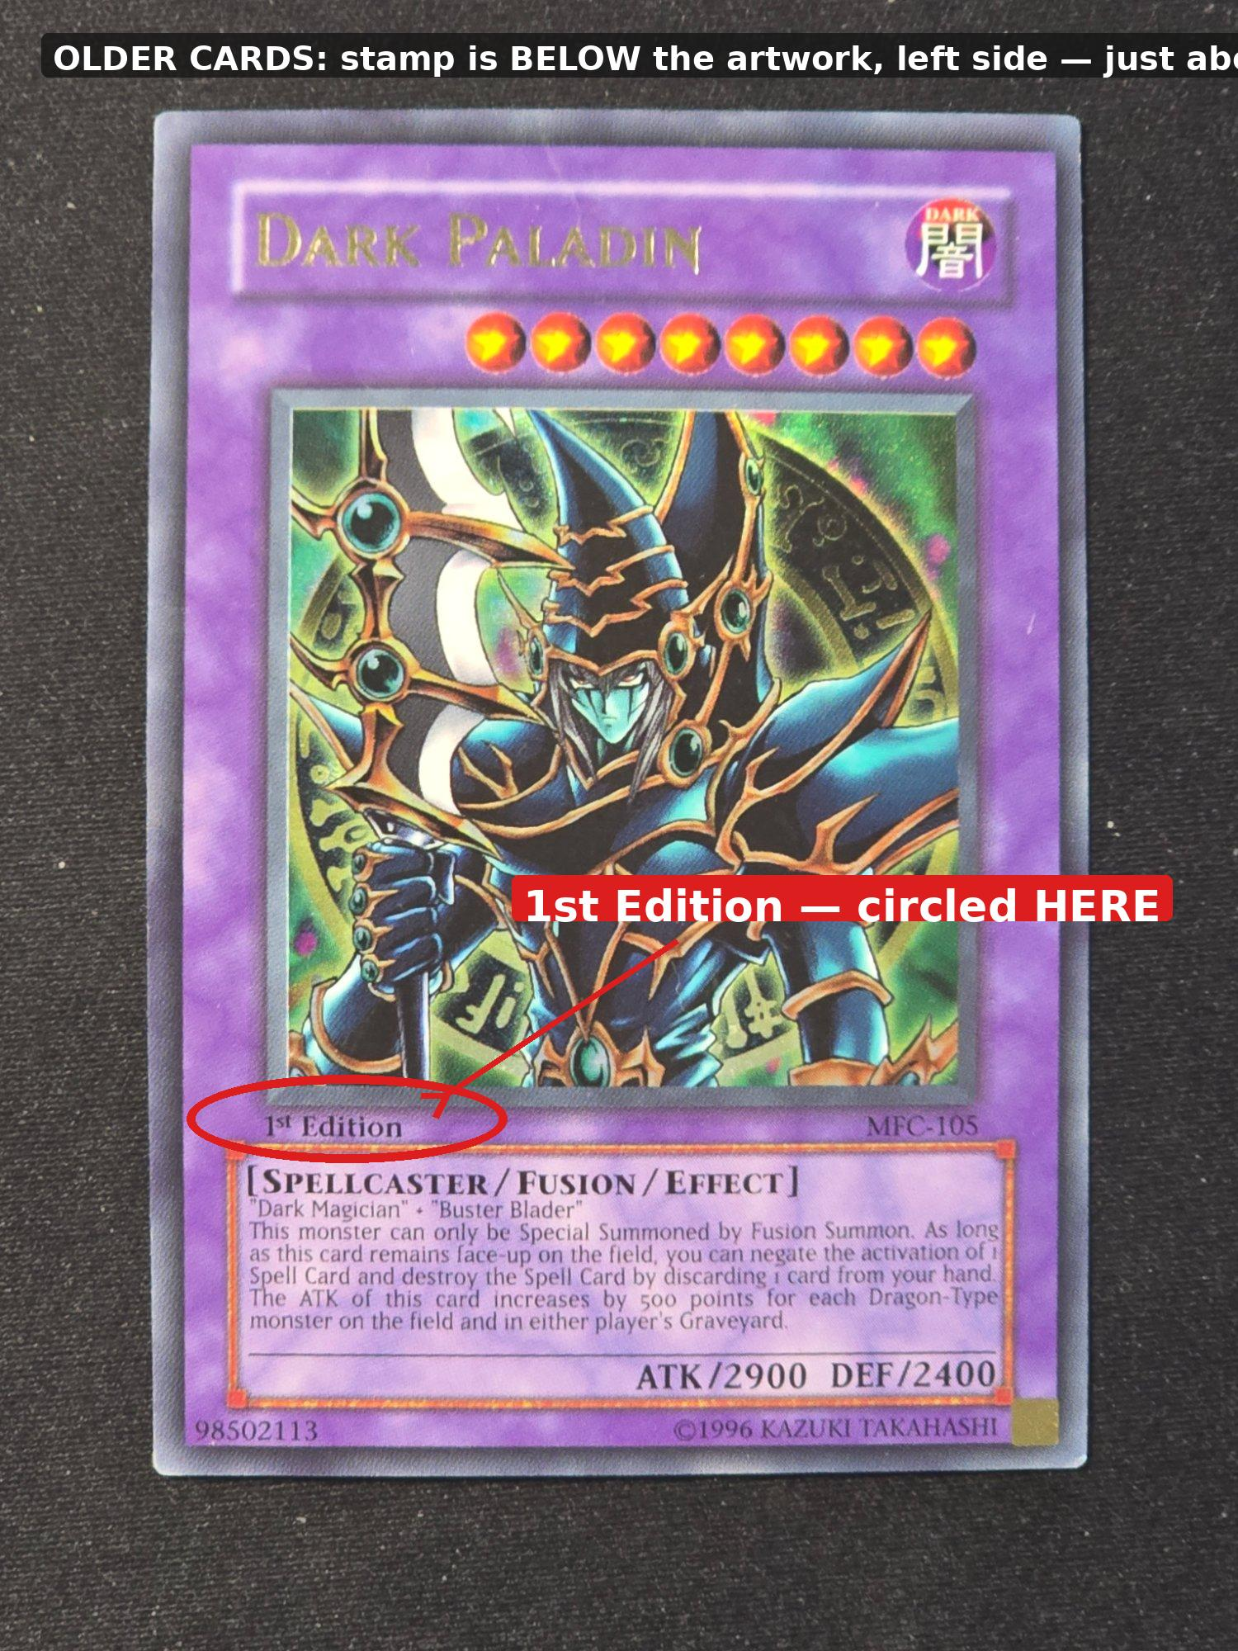
Figure 1a — Dark Paladin (older card): red circle shows '1st Edition' stamp under the artwork, left side

🔎 NEWER CARDS (printed after 2014) — stamp is at the very BOTTOM edge of the card:

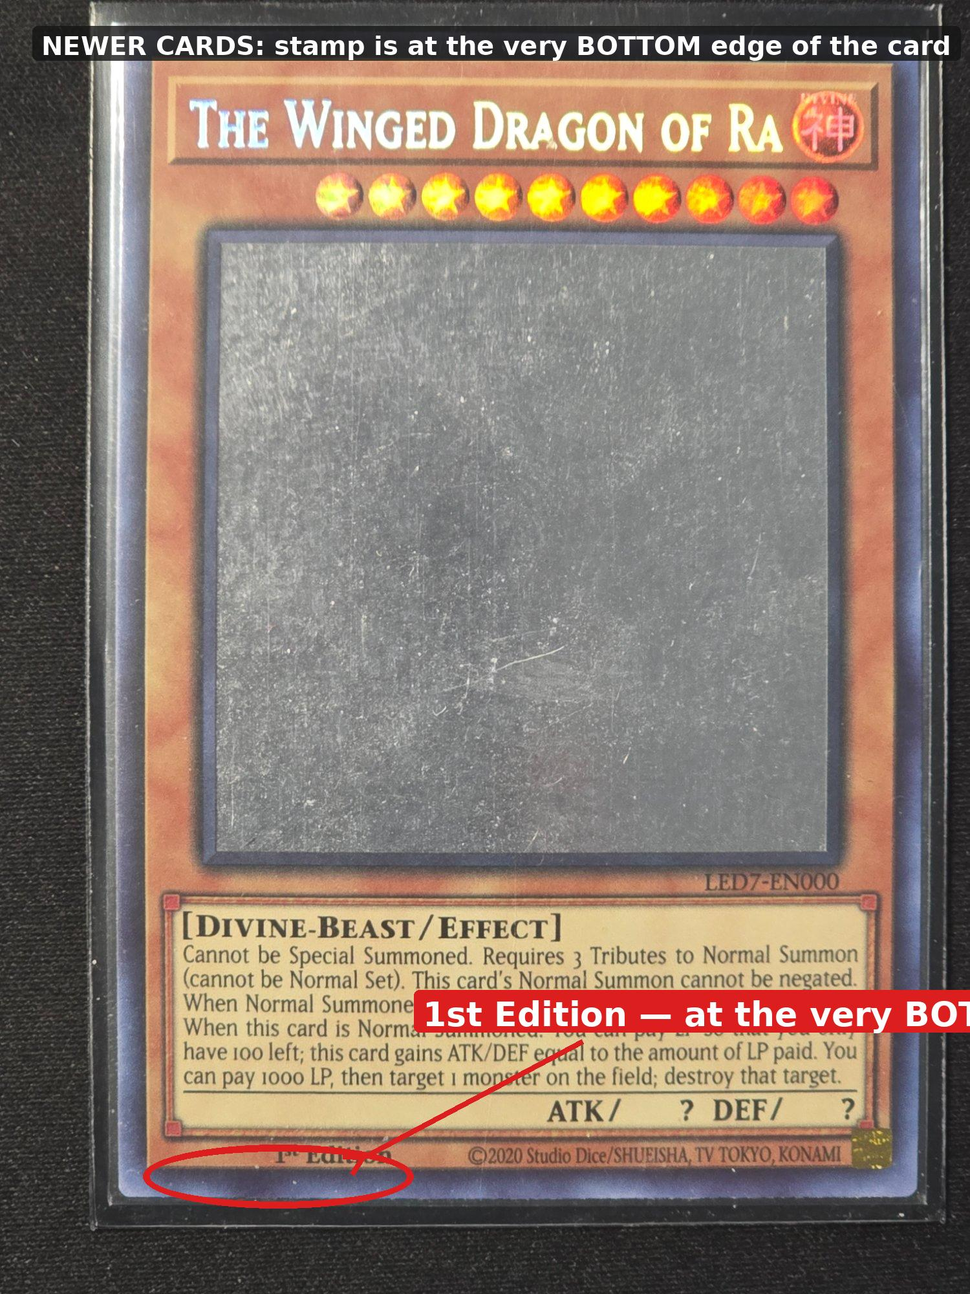
Figure 1b — Winged Dragon of Ra (newer card): red circle shows '1st Edition' at the very bottom footer line

⚠️ | ⚠️ See LIMITED EDITION, DUEL TERMINAL, or any other text in that same spot?  Enter it in the 1st Edition columns — treat it exactly the same as 1st Edition.  Simple rule: ANY text in that spot = 1st Edition. BLANK = Unlimited.

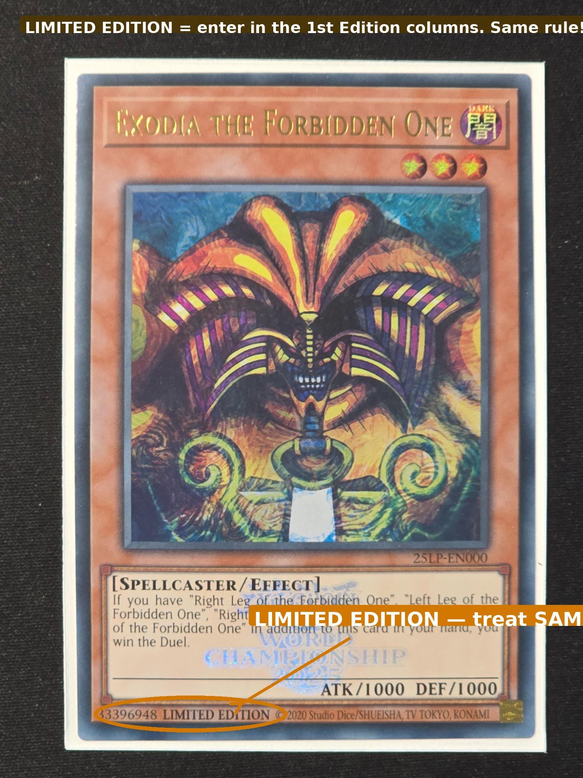  Figure 1c — Exodia: LIMITED EDITION (orange circle) → enter as 1st Edition | 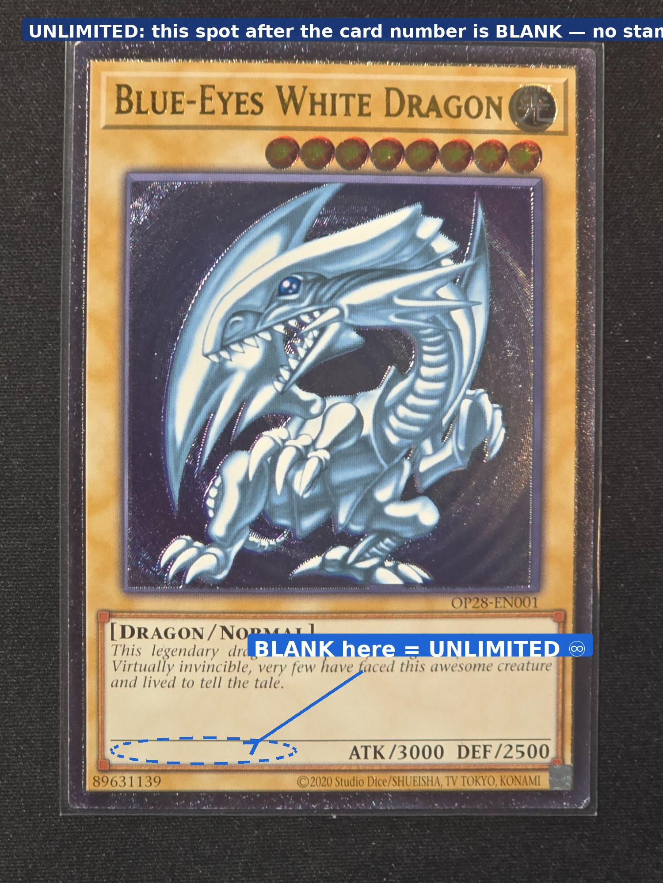  Figure 1d — Blue-Eyes White Dragon: BLANK at bottom → Unlimited ♾️

✅ 1st EDITION (or LIMITED/DUEL TERMINAL)  ANY text in that spot → use the 1st NM / 1st LP / 1st MP columns. | ♾️ UNLIMITED  That spot is BLANK — no text at all → use the Un NM / Un LP / Un MP columns.

SECTION 4 · Understanding Card Condition (NM, LP, MP)

After edition, you need to grade the condition of the card. There are three grades. Look at the FRONT and BACK of the card.

NM | Near Mint | Perfect or near-perfect. No visible wear — edges sharp, corners crisp, surface clean. Looks like it just came out of the pack.
LP | Lightly Played | Minor wear on corners or edges — slight whitening, tiny nicks. Still looks good overall. Light scuffs on the back.
MP | Mod. Played | Noticeable wear — bends, creases, scratches, or heavy edge/corner wear clearly visible. Heavy scratches on the back.

LP Examples — from your collection:

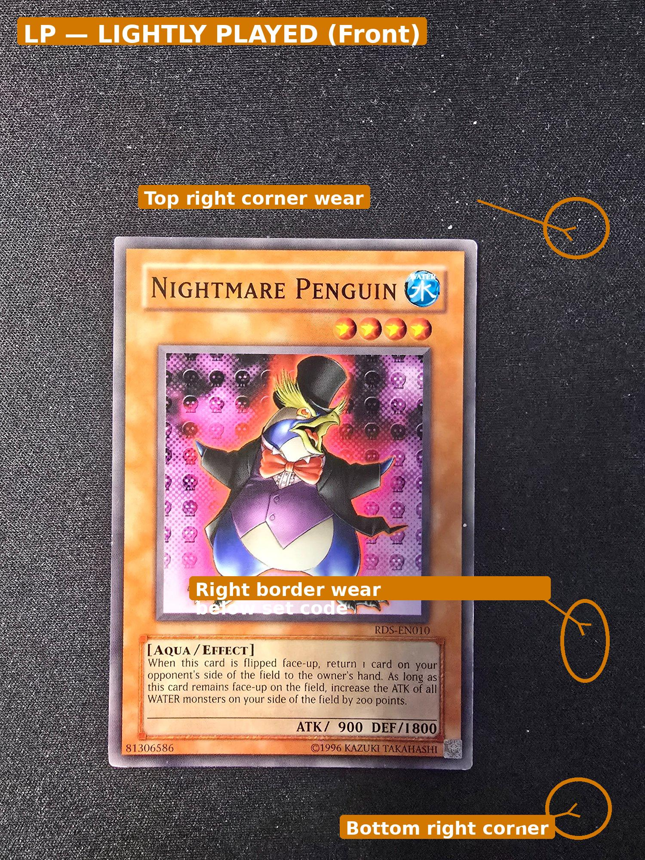  Figure 2a — LP Front (Nightmare Penguin): orange circles show minor corner wear | 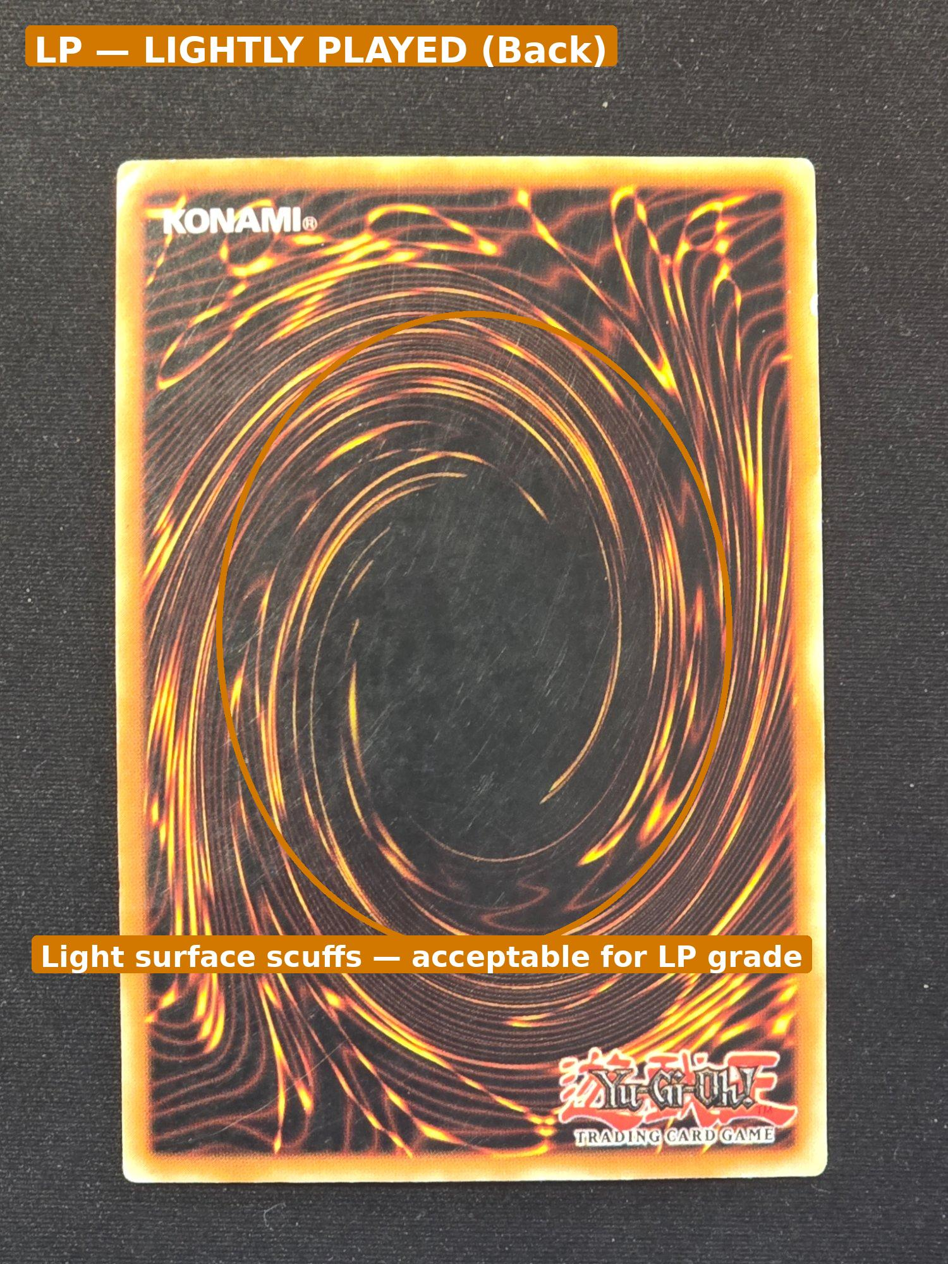  Figure 2b — LP Back: light surface scuffs — still acceptable for LP grade

MP Examples — from your collection:

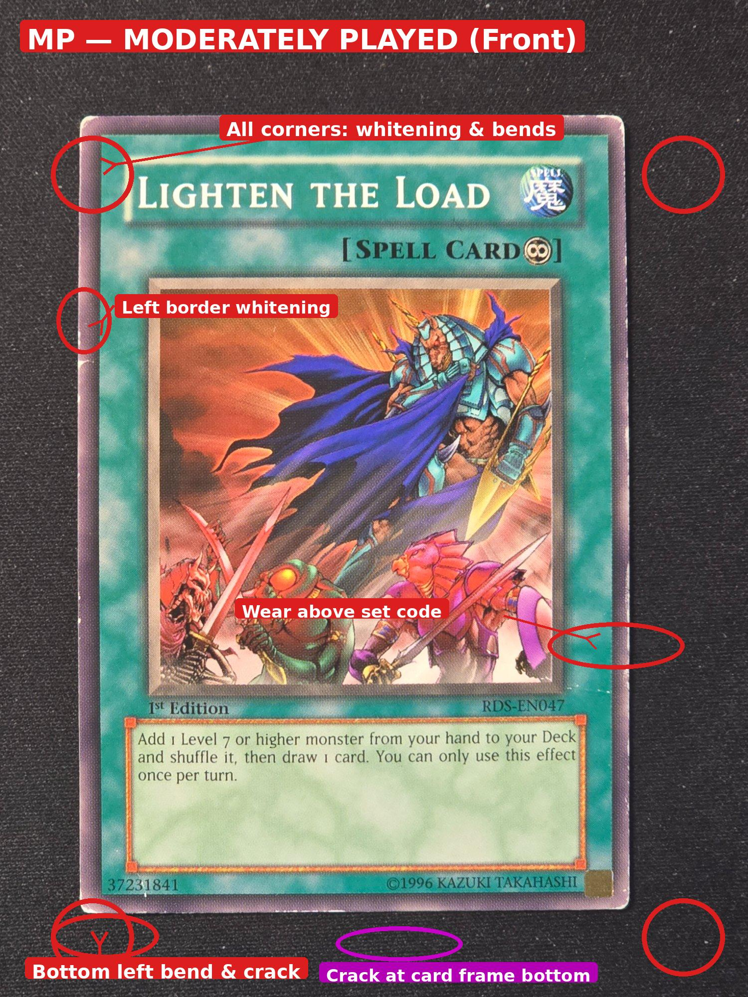  Figure 3a — MP Front (Lighten the Load): red circles on all 4 corners — noticeable wear | 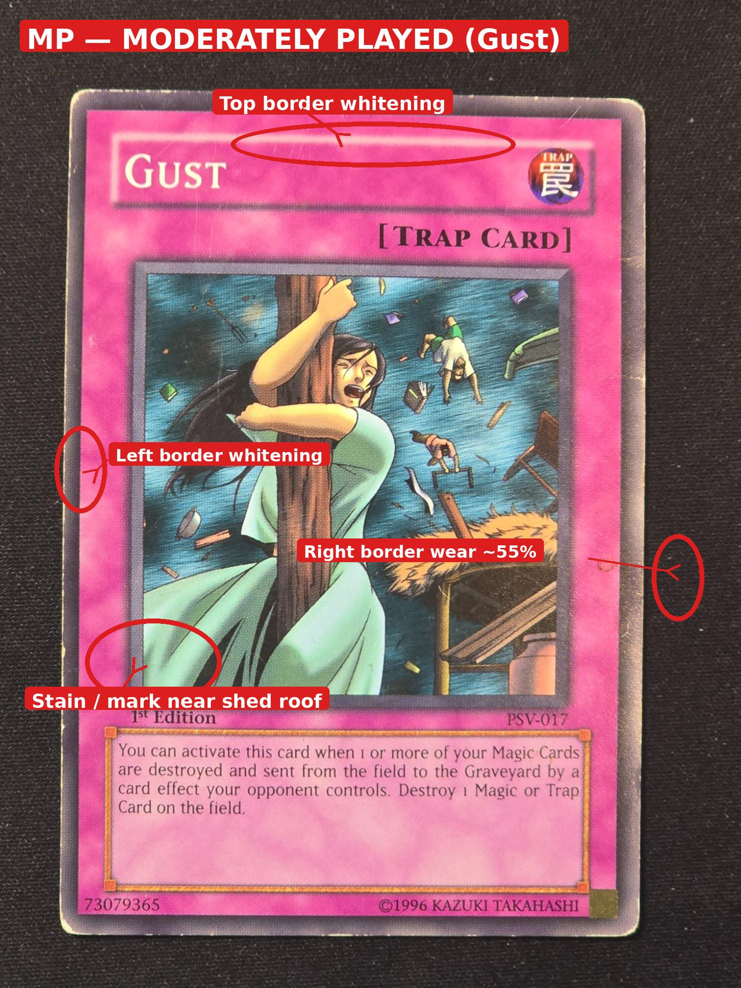  Figure 3b — MP Front (Gust): edge wear and corner whitening clearly visible

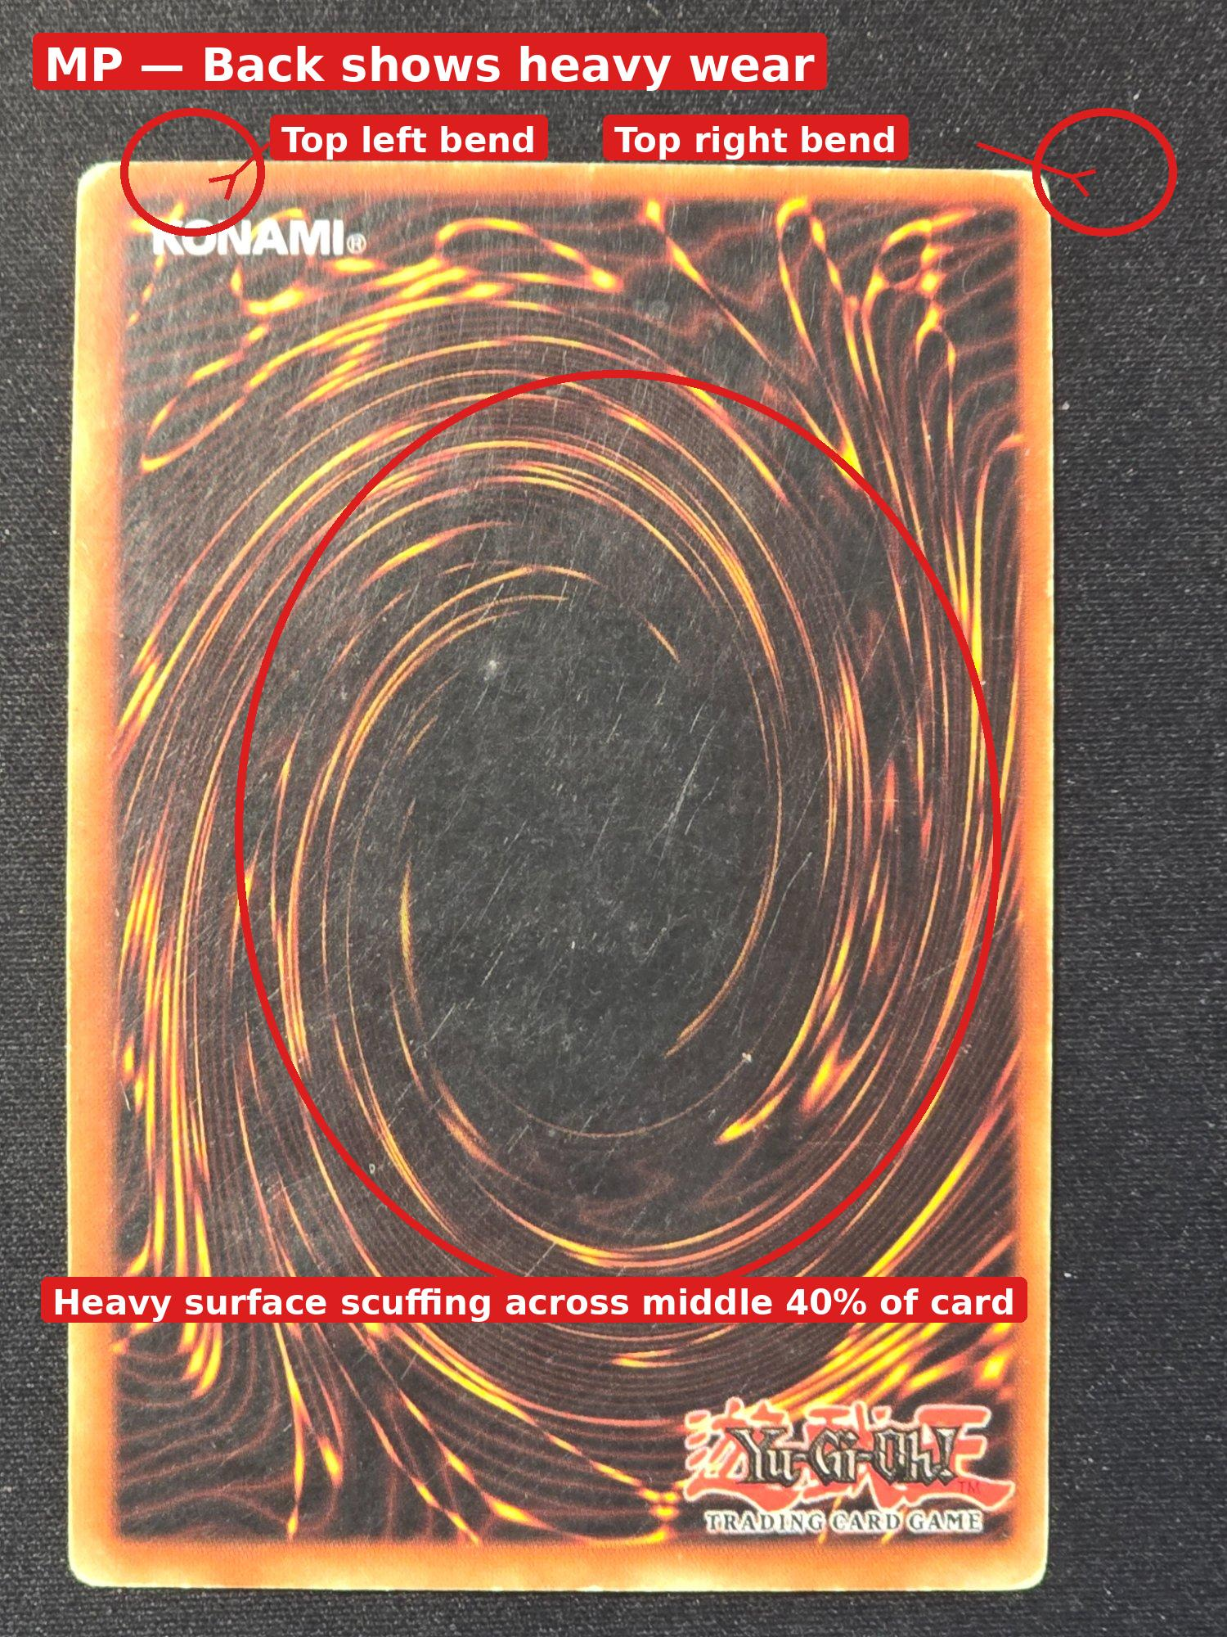  Figure 3c — MP Back: heavy scratches across the back surface = MP or worse |   Figure 3d — Compare to LP back (Fig 2b): LP has lighter, fewer scuffs

⚠️ | When in doubt between NM and LP, go with LP. When in doubt between LP and MP, go with MP. Always better to under-grade than over-grade.

SECTION 5 · Entering a Standard Card into the Inventory Table

Follow these steps for every regular (non-shiny) card. Do NOT use this section for high rarity cards — see Section 6.

📋 | Make sure you have selected the correct SET NAME from the 'What set are you counting?' dropdown at the top before entering any cards.

1 | Find the card row | Scroll down the table to find the row matching your card's Card Number (shown in the bottom-right corner of the card).
2 | Check Edition | Is it 1st Edition or Unlimited? (See Section 3.) This tells you which column group to use.
3 | Check Condition | Is it NM, LP, or MP? (See Section 4.) This tells you which specific column.
4 | Tap the correct cell | Tap where your edition AND condition meet. • 1st Edition + Near Mint → tap '1st NM' • Unlimited + Lightly Played → tap 'Un LP' • 1st Edition + Mod. Played → tap '1st MP'
5 | Type the quantity | Type the number of copies. Usually this is 1.
6 | Confirm and move on | Tap outside the cell to confirm, then move to the next card.
7 | Repeat! | Repeat Steps 1–6 for every card in the pile.

✅ | The total columns (∑) are calculated automatically — you never need to type in those columns.

SECTION 6 · High Rarity Cards — Special Entry Rules

High rarity cards (holographic, shiny, rainbow-pattern) are MORE VALUABLE and must be entered at the BOTTOM of the table in their own section.

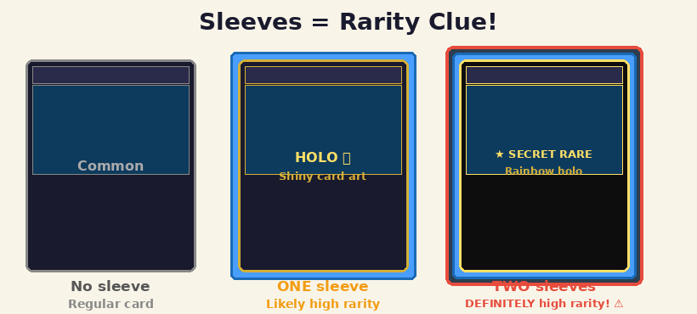
Figure 4 — Use the sleeve count as a quick rarity clue before you even look at the card

🍩 | 🍩 TIMBIT: High rarity cards are almost always in a protective sleeve (a clear plastic cover).  ONE sleeve = likely a high rarity card.  TWO sleeves (a sleeve inside another sleeve) = DEFINITELY high rarity. Treat with extra care!

How to spot a high rarity card:
- The card art is SHINY, HOLOGRAPHIC, or shows a RAINBOW pattern when you tilt it in the light.
- The card name or art has a special texture — raised dots, rainbow foil, or heavy sparkle.
- The card is in a sleeve — and especially if it has TWO sleeves.
- If unsure — check the PLAQUES in the basement. They show physical examples of each rarity type.

How to enter a high rarity card:

1 | Scroll to BOTTOM | Scroll all the way to the BOTTOM of the inventory table. High rarity cards have their own section there.
2 | Find the HR columns | Look for columns labelled 'HR Type', 'HR NM', and 'HR LP'.
3 | Select the Rarity | Tap the 'HR Type' dropdown and SELECT the rarity (e.g. Super Rare, Ultra Rare, Secret Rare). NOT SURE? Go to the basement and check the PLAQUES on the wall.
4 | Edition + Condition | Same as regular cards — check 1st Edition or Unlimited, and grade NM or LP.
5 | Enter the quantity | Tap HR NM or HR LP and type the number of copies.
6 | Save the row | Tap outside or the Save button to confirm.

🍊 Real example — KICO-EN002 Joker’s Knight (Kings Court set)
Going through a collection together, we found 6 copies of this same card:
- 4 copies had GOLD/YELLOW card name text — Ultra Rares. All in One sleeve Enter in 1st Edition NM as 4.
- 2 copies had SILVER/WHITE name text AND a textured rainbow surface — Collector’s Rares. TWO sleeves (card in Tight sleeve inside a penny sleeve). Enter separately as High Rarity NM 2 Collector’s Rare should be already selected in the “Type” text box.
Golden rule: same card name, same set code — but the text colour and card texture reveals the true rarity. More shiny / Super shiny are typically high rarity.
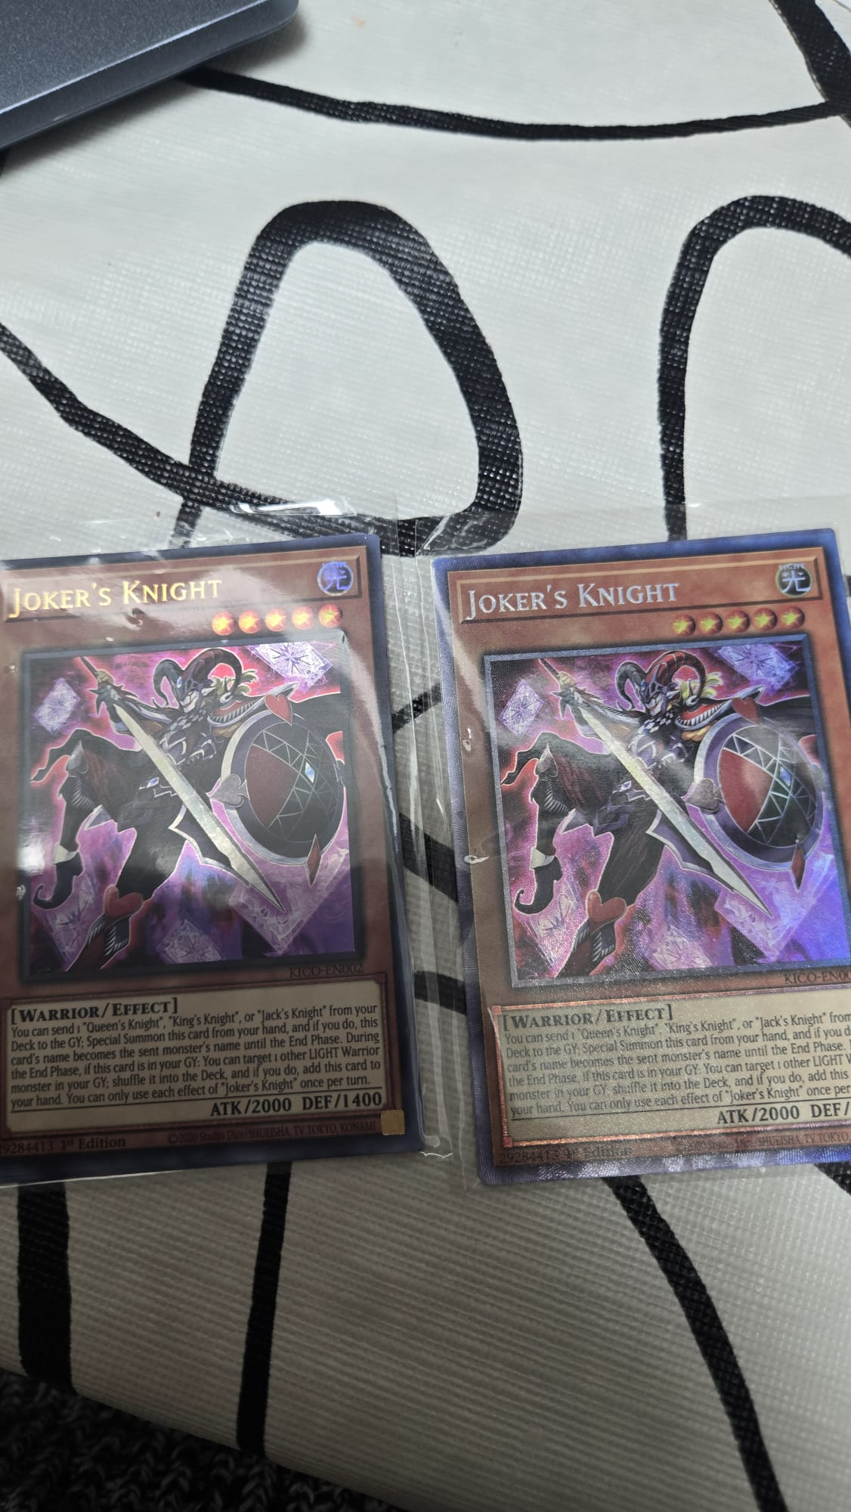
Figure 5 — Joker’s Knight KICO-EN002: gold name = Ultra Rare (1 sleeve) vs silver/textured = Collector’s Rare (2 sleeves)

! | Which rarities go in the HIGH RARITY section?  High rarity = anything ABOVE Secret Rare. This includes:  Ultimate Rare · Ghost Rare · Collector’s Rare · Starlight Rare · Quarter Century Secret Rare · Prismatic Secret Rare  Common, Rare, Super Rare, Ultra Rare, and Secret Rare go in the REGULAR columns — not High Rarity. When in doubt, check the basement plaques.

Quick Rarity Reference — from least to most valuable:

Rarity Name | What it Looks Like
Common | No foil. Plain, flat card art.
Rare | Card NAME is silver/shiny foil. Art is plain.
Super Rare | Card ART is holographic. Name is normal.
Ultra Rare | Card name AND art are both foil/holographic.
Secret Rare | Art has diagonal lines like a fine screen. Very sparkly.
Ultimate Rare | Art has a raised, textured 3D embossed look.
Ghost Rare | Art looks washed-out / ghostly white with depth effect.
Starlight Rare | Like Secret Rare but more detailed lines. Very rare. Very valuable.
Collector's Rare | Swirling rainbow pattern across the whole card.
Quarter Century Secret Rare | Like Secret Rare with extra gold/silver shimmer. 25th anniversary.

❓ | Still not sure? Set the card aside in a separate pile and ask before entering it. Better to ask than enter the wrong rarity.

SECTION 7 · Quick Reference Cheat Sheet

I see '1st Edition' printed on card | → Use the 1st NM / 1st LP / 1st MP columns
See 'LIMITED EDITION' or 'DUEL TERMINAL' | → Same as 1st Edition — use the 1st columns
The bottom-left spot is BLANK | → Use the Un NM / Un LP / Un MP columns
Card looks perfect — no wear | → NM (Near Mint)
Small corner or edge wear | → LP (Lightly Played)
Bends, creases, or scratches | → MP (Moderately Played)
Card is shiny / holographic | → HIGH RARITY — scroll to bottom of table
Card has TWO sleeves | → DEFINITELY high rarity — check plaque in basement!
Not sure what rarity it is | → Check the plaques in the BASEMENT

⭐ | 📞 Questions or not sure? Set the card aside and ask before entering it.  🍩 REMEMBER: Two sleeves = HIGH RARITY. Always!

SECTION 8 · Day-to-Day Card Entry Decision Flow

Use this diagram every time you sit down to enter cards. Start at the top, answer each question, and follow the arrow for your path. 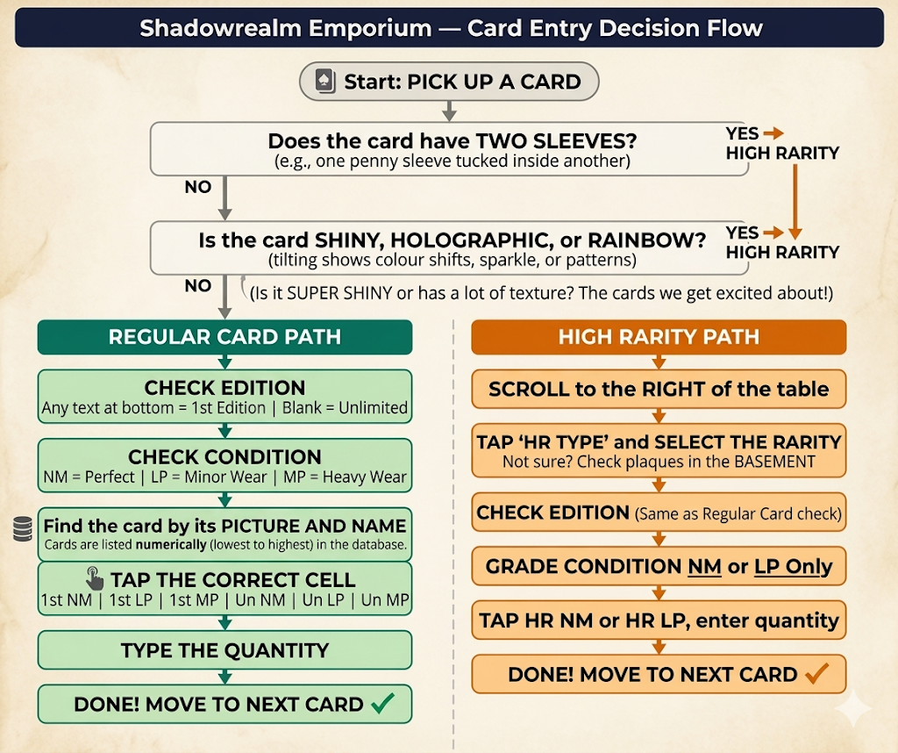

Figure 6 — Card entry decision flow. Start at 'Pick up a card' and follow the arrows.

ℹ️ | START: Pick up a card → 2 sleeves? YES → High Rarity Path. NO → Shiny? YES → High Rarity Path. NO → Regular Card Path.  Regular path: check edition → check condition → find row → tap cell → enter qty → done.  High rarity path: scroll to bottom → select HR type → check edition → grade condition → enter qty → done.

Shadowrealm Emporium · shadowrealmemporium.netlify.app

